**Accessibility Testing / ADA (American Disability Act) / 508 Compliance testing**

Accessibility testing is the practice of making your web and mobile apps usable to as many people as possible. It makes apps accessible to those with disabilities, such as vision impairment, hearing disabilities, and other physical or cognitive conditions.

ensure that the application being tested is usable by people with physically challenged/ disabilities like hearing, color blindness, old age and other disadvantaged groups

Here the physical disability could be old age, hearing, color blindness, and other underprivileged groups.

For example, Suppose if a blind person is accessing the Internet – the application should be in such a way that even the physically challenged person should be able to access it without any problems.

When a blind person clicks on anything – the response connected into voice & the person heras & uses it – Response sent should be easily read by the browser & commented in voice

In the above example, whatever the respond is sent to the browser should be easily read – the application should be designed like that – the respond sent should be immediately connected into voice. Thus, the blind person can use it without facing any problem

Red & Green color should not be used

All comments should have Alt tags

Red & Green color objects should not be displayed

Should be able to access all components just by using the keyboard.

Like this, there are many rules.

**The 508 testing has got some rules that should be followed while developing the application. Some of the rules are,**

* **Special keyboard:** We have some special keyboards where the users can quickly type, and these keyboards are specially designed for them who have motor control problems.
* **Screen reader software**: This type of software is used to read out the text, which is shown on the screen.
* **Speech Recognition Software:** The speech recognition software will change the spoken word to text and works as an input to the computer system.
* **Screen Magnification Software:** This type of software is designed to help the vision-impaired persons because it will expand the screen and make the reading easy.

## **Example of accessibility testing**

Let us assume that if a blind person uses the internet, and clicks on anything, the response connected into the voice, and the person can hear that and then uses it. The response should be read by the browsers and commented invoice.

Whatever the response is sent to the browser, it can be easily read, and the application or the software should be designed like that. The response should be immediately connected to voice. Therefore the blind person can easily access it.

The application should be designed in such a way that even the physically impaired person could be able to access the application without facing any difficulties.

**You need to test/ Checkpoints for Accessibility Testing**

* Labels — Used by assistive technologies, like VoiceOver or TalkBack.
* Text contrast — Ratio between text or images and background color.
* Hit area size — Area designated for user interaction.
* View hierarchy of UI — Determines how easy the Android app is to navigate.
* Dynamic font size — Option for users to increase font size to fit their needs.
* Verify whether Tabs are ordered logically to ensure the smooth navigation
* Whether the instructions are provided as a part of the user documentation or manual
* Whether shortcut keys are provided for menus
* Whether response time of each screen or page is clearly mentioned so that End Users know how long to wait
* Whether an application has audio alerts
* Whether a user is able to adjust audio or video controls
* Whether user can adjust or disable flashing, rotating or moving displays
* Whether audio and video related content are properly heard by the disability people ? Test all multimedia pages with no speakers in websites
* Whether training is provided for users with disabilities that will enable them to become familiar with the software or application?

### **How to Perform Accessibility Testing**

We can perform accessibility testing both **manually** and with the help of **automation** as well

* **Modifying the font size to large:** We can use the large font size and check the availability.
* **Testing for captions:** Here, we will test that a caption should be visible and also ensure that it is expressive. As we know that while we are accessing the Facebook application, sometimes the images and videos take lots of time to load, where the captions will help us to understand what is in the pictures and video.
* **By deactivating the style:** We can disable the method and test if the content of the table is accurately lined up or not.
* **We can use high contrast mode:** If we can use high-contrast mode, we can highlight the website's content. When we turn the high contrast mode in our windows, the content of the site gets highlighted automatically as it turns into white or yellow, and the background turns black.
* To turn on **high contrast mode**, search the **high contrast mode** in the search box of the start menu on your system as we can see in the below image:

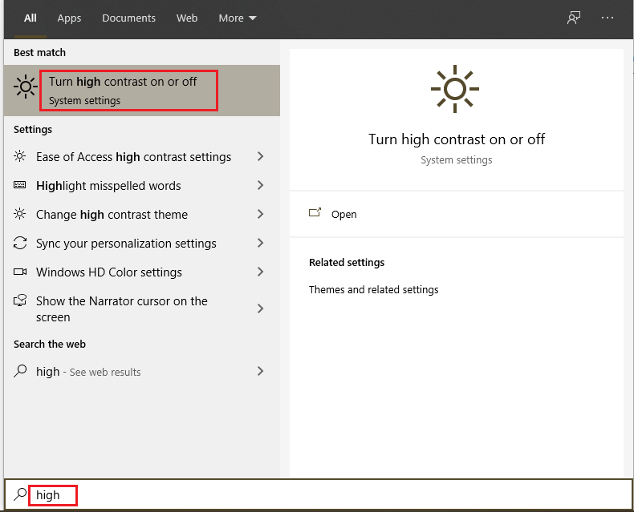

* first we **turn-on the high-contrast,** and we can also select a **theme** from the given drop-down list as we choose the **high contrast** theme as we can see in the below image:

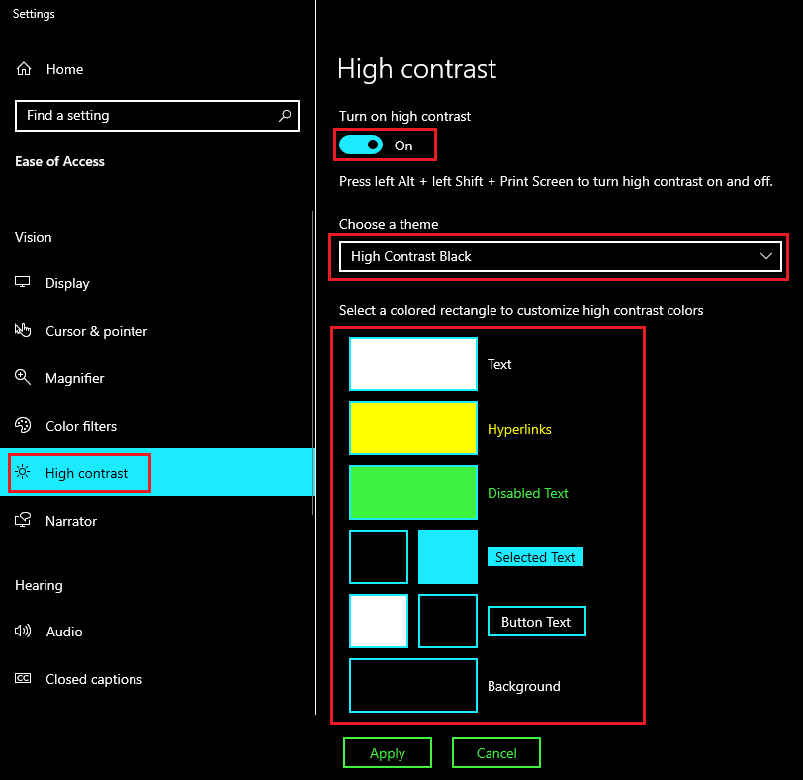

After modifying the settings, our browser will look like this:

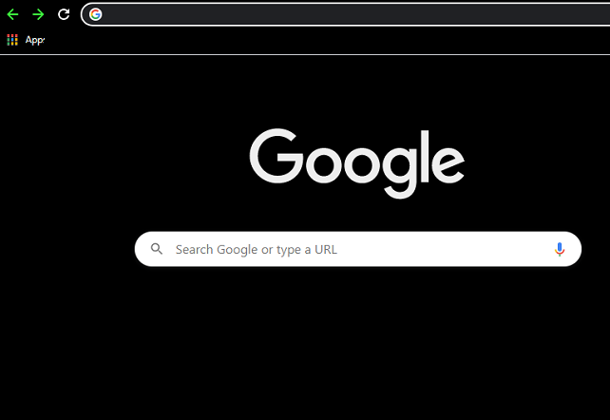

* **Skip navigation:** We can also skip the navigation sometimes as it is helpful for people who have motor incapacities. We can change our effort to the top of the page by clicking on the **Ctrl + Home**
* Use the field label: If we use the field label as it will help us in filing a form because this, we can see the template and fill out the required information while we are ordering something online and login.
* PDF document: In we can try to save the PDF file in the form of text and test whether the order for the content is kept or not.

**Websites Accessibility Tools:**

* Sort Site
* Hera
* Accessibility valet
* TAW
* WebAnywhere
* Web accessibility toolbar